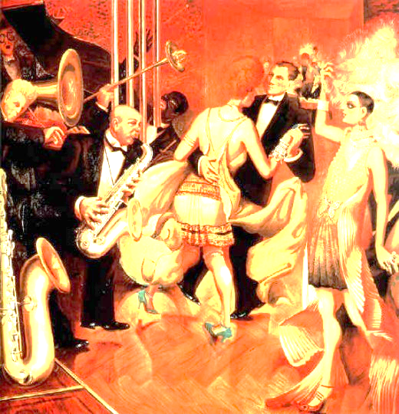
SOURCE A:

‘Big City’: a painting by Otto Dix from 1927

SOURCE B:
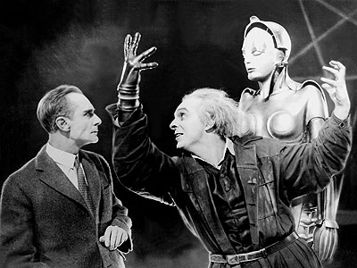
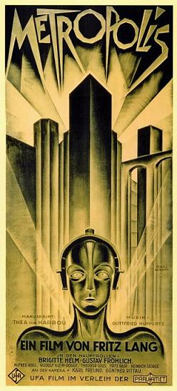
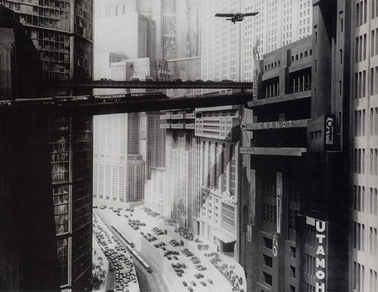

Poster and Film Scenes from ‘Metropolis’ (1927) a film from the Weimar Republic
SOURCE C:

"The city had a jewel-like sparkle," she said, "the vast cafés reminded me of ocean liners powered by the rhythms of their orchestras. There was music everywhere."

- Description of Berlin by an American dancer visiting the city in 1925

SOURCE D:
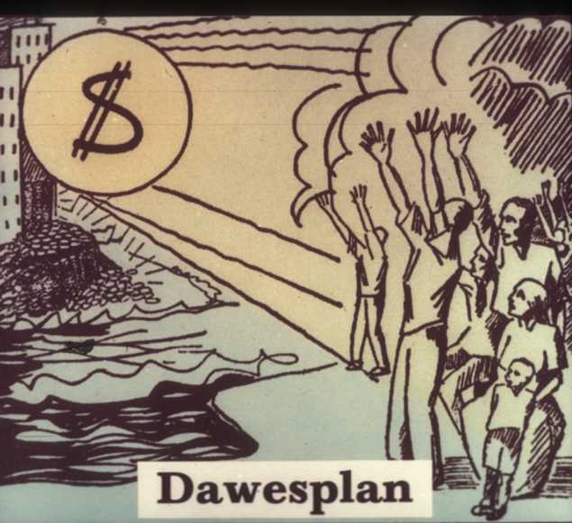
Communist Party poster protesting the Dawes Plan: a 1924 agreement giving Germany loans from the USA to help the economy.

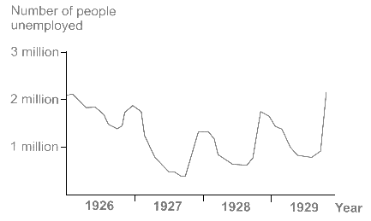
Source E:

Graph showing numbers of unemployed in the Weimar Republic

